SmartPark AI – Project Documentation

1. Introduction
SmartPark AI is a smart parking management system designed to automate vehicle slot booking, tracking, and checkout operations. It provides a real-time visualization of parking slot availability along with live vehicle tracking and history logging.

2. Objectives
- To manage parking slots efficiently
- To reduce manual parking allocation
- To provide real-time slot status
- To maintain parking history records

3. Technologies Used
- HTML5 for structure
- CSS3 for styling and UI design
- JavaScript for logic and interactivity
- Google Fonts (Orbitron) for futuristic UI

4. System Features
• Parking Slot Grid (40 slots)
• Slot Booking System
• Vehicle Search
• Live Vehicle Tracking
• Checkout Facility
• Slot History Logging

5. Module Description
a) Parking Grid:
Displays all parking slots with color-coded status (Free / Booked).

b) Register Slot:
Allows users to enter name, vehicle number, vehicle type, and slot number.

c) Search Vehicle:
Searches the parking area using vehicle number.

d) Live Tracking:
Shows all currently parked vehicles in real time.

e) Checkout Vehicle:
Frees the slot when the vehicle exits.

f) Slot History:
Maintains a table of all parked vehicles with time stamps.

6. Working Principle
• Slots are initialized as free
• User books a slot using the form
• Slot status changes to booked
• Live tracking updates automatically
• Checkout resets the slot
• All activities are logged in history

7. Advantages
- Easy to use interface
- Real-time monitoring
- Reduces human error
- Scalable for large parking areas

8. Limitations
- No database (data resets on refresh)
- No authentication system
- Limited to client-side execution

9. Future Enhancements
- Database integration
- AI-based slot prediction
- Mobile app version
- QR code based entry/exit

10. Conclusion
SmartPark AI demonstrates an efficient and user-friendly approach to smart parking management. With further enhancements, it can be scaled into a real-world smart city solution.

11. System Architecture Diagram
The following diagram shows the high-level architecture of SmartPark AI.
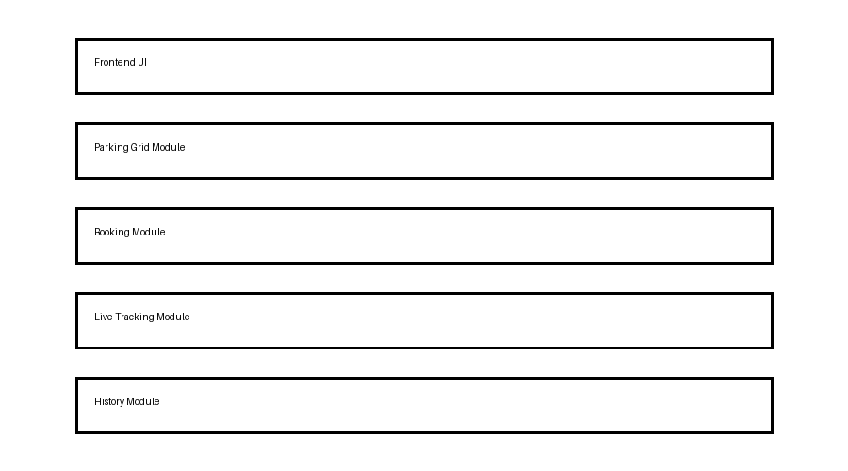

12. System Flow Diagram
The flow diagram explains how user actions are processed in the system.
